**O2 measurement viva** Alex Hunter 2020

Opening question to be read exactly:

“**How can we measure oxygen”**

*Allow candidates to list methods and then explore in detail their understanding of as many methods as time allows.*

1. Paramagnetic analyser
2. Clarke (polargraphic) electrode
3. Fuel Cell
4. Mass spectroscopy
5. Others (Gas chromatography, Raman Spectometry) *(allow candidate to discuss if they have successfully explained the above)*
6. **Paramagnetic analyser**

Paramagnetic oxygen analysers are the most common form of oxygen analyser used in the operating theatre.

* This works on the principle that **oxygen** (along with nitric oxide) is a **strongly paramagnetic** gas and is attracted into a magnetic field by the virtue of having **unpaired electrons in their outer electron ring**.
* (older cells, a dumb-bell and torsion wire system was used. Now modern systems use a switched electromagnetic field and pressure transducer.)
* The paramagnetic analyzer works on the principle that **O2 is attracted towards a magnetic field (due to the unpaired electrons in its outer shell).**
* The **analyzer measures the pressure differential** **between a stream of reference gas (e.g. air) on one side and the sample gas on the other**, when exposed to an alternating magnetic field. A sensitive **pressure transducer** is used to **convert this pressure difference into an electrical signal** calibrated to give the partial pressure of O2 on the sample.

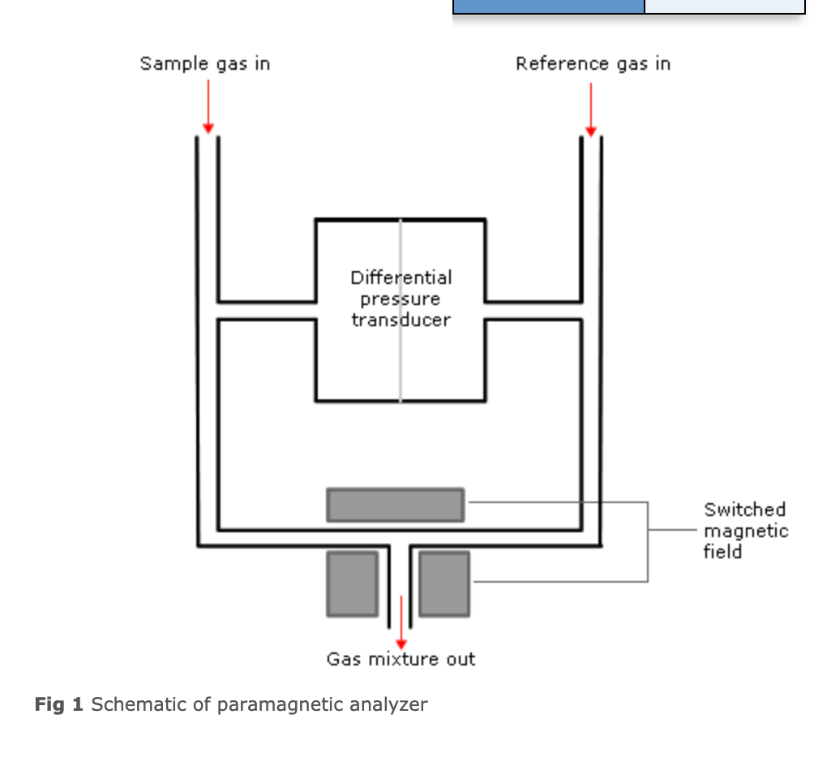

**2. Clarke electrode**

Often used for dissolved pO2 eg in blood gas machine

PO2 is measured using the Clark electrode, also known as a polarographic electrode or oxygen electrode.

The Clark electrode comprises of a platinum cathode,

and a silver/silver chloride anode,

which form a circuit via an electrolyte solution – normally KCl.

It is powered by a 0.6 V battery.

Electrons are formed at the anode from its reaction with the KCl. The electrons then react with O2 (which diffuses into the electrolyte solution through a plastic membrane) and water at the cathode to produce hydroxyl ions (see below).

**This generates a current.**

**By measuring the current generated by the O2/electron reaction, which is dependent on the amount of O2 at the cathode, the O2 concentration can be found:**

O2 + 4e + 2H2O → 4(OH)-

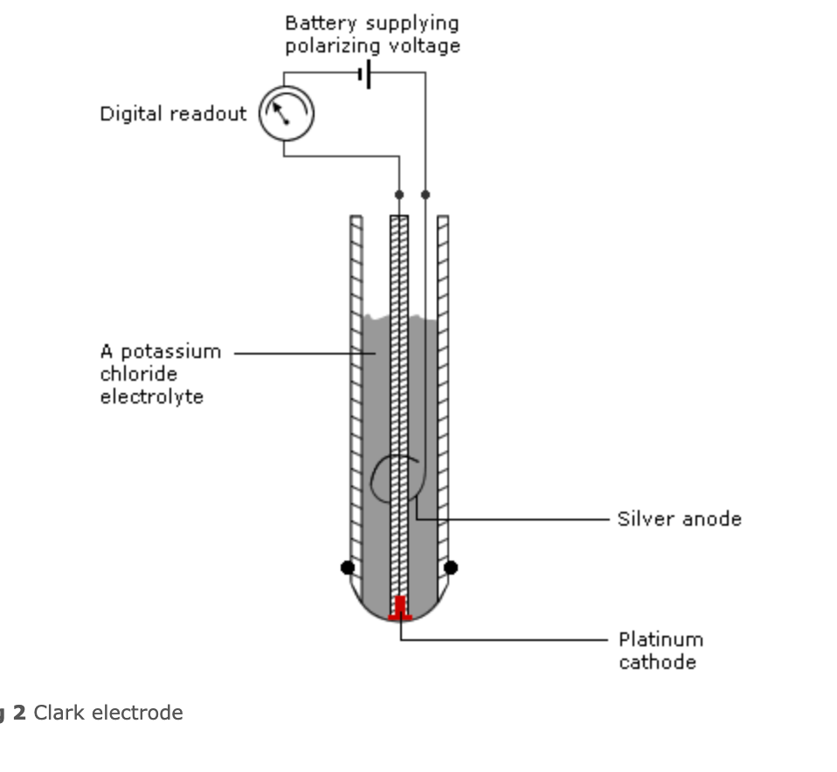

1. **Fuel Cell**

This is similar to the polarographic sensor, but the electrodes are chosen to provide their own current.

The cathode is often gold or silver, and the anode is usually lead, with potassium hydroxide as the electrolyte solution.

The flow of electrons is proportional to the concentration of oxygen present.

The anode is sacrificial, the system is temperature and acid sensitive, and can take a while to recover after exposure to high concentrations of oxygen (oxygen shock).

They have a limited life span but can be made relatively cheaply.

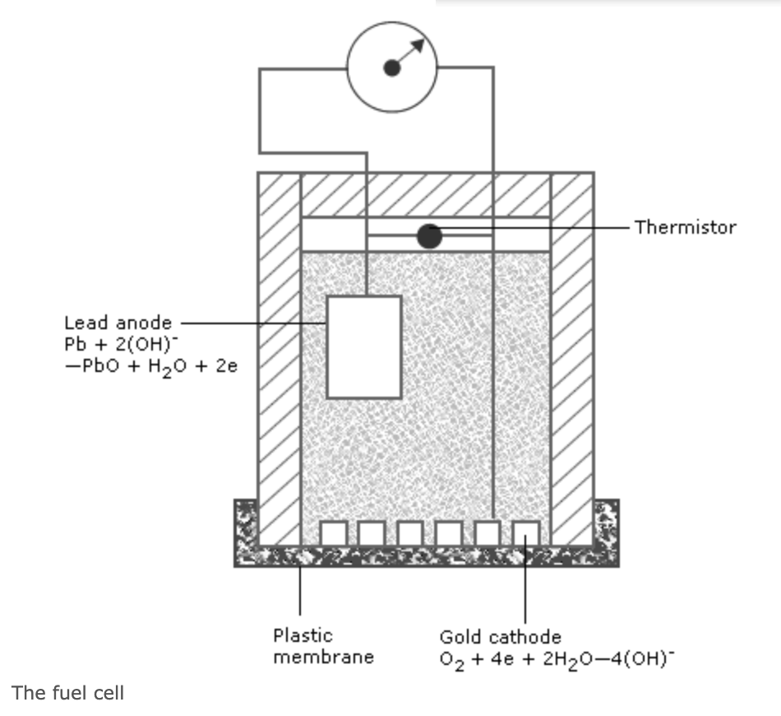

1. **Mass Spectrometry**

A few molecules of the gas sample enter an ionization chamber where they are bombarded by electrons that are moving from a hot cathode to an anode.

This forms **charged fragments** from the gas molecules, of varying molecular weight.

These are then **accelerated and focussed onto the detector** using either a **magnetic field** or electrically charged rods.

By varying the current to the magnet/rods, fragments of a particular size can be focussed on to the detector, as the **amount of deflection depends on their mass**.

If a **fragment that is unique to a particular gas molecule is selected, the concentration of that gas can be measure from the output of the detector**.

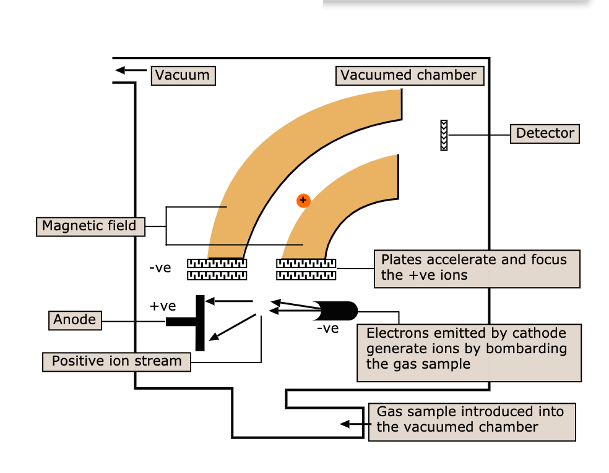

Sources:

Elearning for health

<https://academic.oup.com/bjaed/article/9/1/19/465989>

https://www.frca.co.uk/article.aspx?articleid=100389